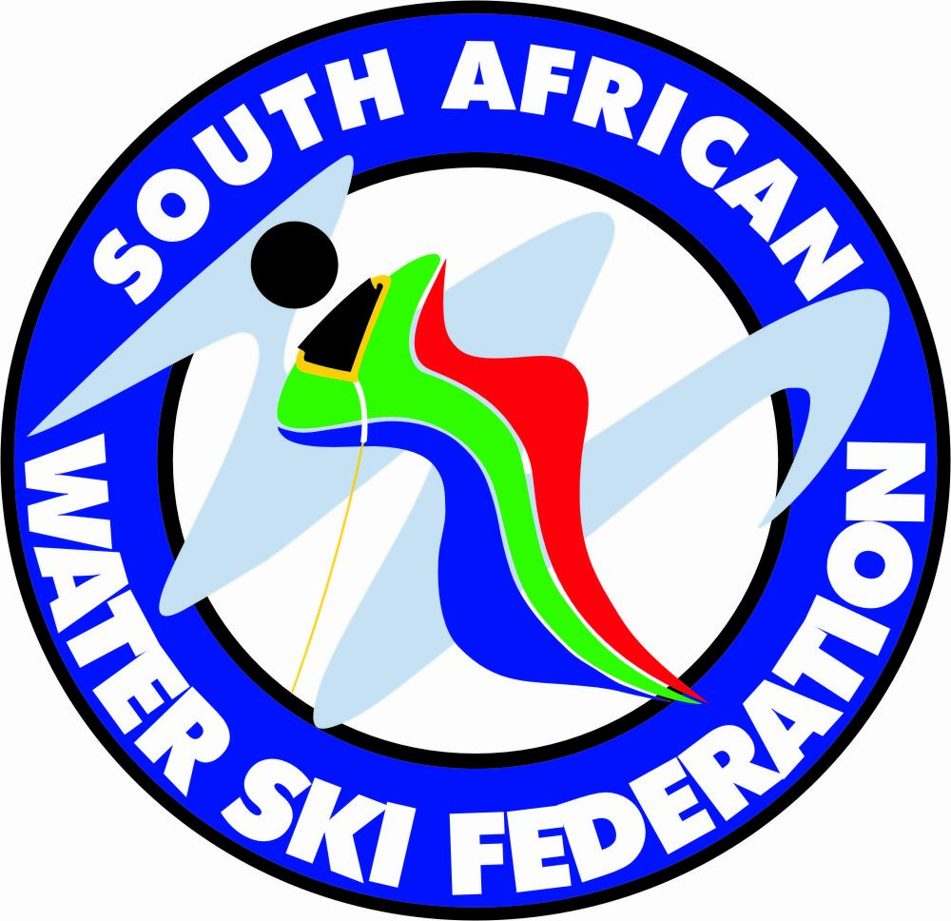 | 2011 E&A wakeboard and Wakeskate Championships  Emerald Casino resort, Vanderbijlpark, South Africa - 15/18 Feb 2012

2011 E&A wakeboard and Wakeskate Championships

Boys Wakeboard Final results

Homologation: E&A Championships - 15.02.2012 - 18.02.2012
 | Name | Country |  | Categ. | Score | Execution | Intensity | Composition
1 | Caimi Nicolo | ITA |  | Boys | 55.00 | 17.87 | 18.70 | 18.43
2 | Firer Guy | ISR |  | Boys | 49.23 | 15.98 | 17.59 | 15.65
3 | Eames Harry | *GBR |  | Boys | 44.44 | 14.43 | 14.92 | 15.10
4 | Terskov Nikita | RUS |  | Boys | 40.78 | 13.54 | 14.14 | 13.10
5 | Zwartjes Tom François | FRA |  | Boys | 37.00 | 11.77 | 12.80 | 12.43
6 | Kushkovskiy Sergey | RUS |  | Boys | 23.00 | 7.22 | 8.35 | 7.44

